CHAPTER 1
Introduction
  - Background
In 2007, a group of handset manufacturers, wireless carriers, and software developers (notably, Google) formed the Open Handset Alliance, with the goal of developing the next generation of wireless platform. Unlike existing platforms, this new platform would be nonproprietary and based on open standards, which would lead to lower development costs and increased profits. Mobile software developers would also have unprecedented access to the handset features, allowing for greater innovation.

In 2008, the Open Handset Alliance announced the Android platform and launched a beta program for developers. Android went through the typical revisions of a new platform. Several prerelease revisions of the Android Software Development Kit (SDK) were released. The first Android handset (the T-Mobile G1) began shipping in late 2008. Throughout 2009, more Android handsets and diverse types of devices powered by Android reached world markets.


Fig1.1 Android Logo

Android delivers a complete set of software for mobile devices: an operating system, middleware and key mobile applications. Android was built from the ground-up to enable developers to create compelling mobile applications that take full advantage of all a handset has to offer. It was built to be truly open. For example, an application can call upon any of the phone's core functionality such as making calls, sending text messages, or using the camera, allowing developers to create richer and more cohesive experiences for users. Android is built on the open Linux Kernel. Furthermore, it utilizes a custom virtual machine that was designed to optimize memory and hardware resources in a mobile environment. Android is open source; it can be liberally extended to incorporate new cutting edge technologies as they emerge. The platform will continue to evolve as the developer community works together to build innovative mobile applications.

Android provides access to a wide range of useful libraries and tools that can be used to build rich applications. For example, Android enables developers to obtain the location of the device, and allows devices to communicate with one another enabling rich peer-to-peer social applications. In addition, Android includes a full set of tools that have been built from the ground up alongside the platform providing developers with high productivity and deep insight into their applications.

Android does not differentiate between the phone's core applications and third-party applications. They can all be built to have equal access to a phone's capabilities providing users with a broad spectrum of applications and services. Android breaks down the barriers to building new and innovative applications. For example, a developer can combine information from the web with data on an individual's mobile phone — such as the user's contacts, calendar, or geographic location — to provide a more relevant user experience.

  - Significance of the project
The Google Android operating system is known for its intuitive design, support for multiple networks and the ability for framing various applications. Android applications are written in Java - a relatively easy to learn, friendly language for new developers. In this generation of mobile technology, Android has shown its presence attracting both users and Android programmers. Mobile apps are now catching up at a rapid fire pace, it can be security applications, fun applications, business applications, internet applications, utility applications and many more can be run on a smartphone platform. As users are multiplying immensely with the demands of both custom and customized applications for their respective devices, most of the leading smartphone manufacturers are playing major role to thrive in it. High performance and quality applications can be developed by using the SDK as it provides great built-in features as well as high level flexibility to develop smart mobile applications.

With the increasing demand for the applications in smart phones one such application which attracted our attention was an application that helped the user to easily create and share his business card. The need for a business man to quickly create different business cards for different persons and that too within his phone had lead to our development of cardZcreator.

  - Aim
CardZcreator is an application developed for android devices especially for android mobile phones. It is used to create cards and save them for later sharing. This application provides the user with 20 predefined designs for the creation of visiting/business cards, greeting cards and wedding cards. The user can also develop his own card. A blank frame is provided to the user in this case and he can develop a card based on his requirements and desired design.

  - Methodology
1.4.1 Application Basics
Android applications are written in the Java programming language. The Android SDK tools compile the code—along with any data and resource files—into an Android package, an archive file with an .apk suffix. All the code in a single .apk file is considered to be one application and is the file that Android-powered devices use to install the application.
Once installed on a device, each Android application lives in its own security sandbox:
- The Android operating system is a multi-user Linux system in which each application is a different user.
- By default, the system assigns each application a unique Linux user ID (the ID is used only by the system and is unknown to the application). The system sets permissions for all the files in an application so that only the user ID assigned to that application can access them.
- Each process has its own virtual machine (VM), so an application's code runs in isolation from other applications.
- By default, every application runs in its own Linux process. Android starts the process when any of the application's components need to be executed, then shuts down the process when it's no longer needed or when the system must recover memory for other applications.

1.4.2 Application Components
Application components are the essential building blocks of an Android application. Each component is a different point through which the system can enter your application. Not all components are actual entry points for the user and some depend on each other, but each one exists as its own entity and plays a specific role—each one is a unique building block that helps define your application's overall behavior.
There are four different types of application components. Each type serves a distinct purpose and has a distinct lifecycle that defines how the component is created and destroyed.
Here are the four types of application components:
Activities
An activity represents a single screen with a user interface. For example, an email application might have one activity that shows a list of new emails, another activity to compose an email, and another activity for reading emails. Although the activities work together to form a cohesive user experience in the email application, each one is independent of the others. As such, a different application can start any one of these activities (if the email application allows it). For example, a camera application can start the activity in the email application that composes new mail, in order for the user to share a picture.

Services
A service is a component that runs in the background to perform long-running operations or to perform work for remote processes. A service does not provide a user interface. For example, a service might play music in the background while the user is in a different application, or it might fetch data over the network without blocking user interaction with an activity. Another component, such as an activity, can start the service and let it run or bind to it in order to interact with it.
Content providers
A content provider manages a shared set of application data. You can store the data in the file system, an SQLite database, on the web, or any other persistent storage location your application can access. Through the content provider, other applications can query or even modify the data (if the content provider allows it). For example, the Android system provides a content provider that manages the user's contact information. As such, any application with the proper permissions can query part of the content provider to read and write information about a particular person. Content providers are also useful for reading and writing data that is private to your application and not shared.
Broadcast receivers
A broadcast receiver is a component that responds to system-wide broadcast announcements. Many broadcasts originate from the system—for example, a broadcast announcing that the screen has turned off, the battery is low, or a picture was captured. Applications can also initiate broadcasts—for example, to let other applications know that some data has been downloaded to the device and is available for them to use. Although broadcast receivers don't display a user interface, they may create a status bar notification to alert the user when a broadcast event occurs. More commonly, though, a broadcast receiver is just a "gateway" to other components and is intended to do a very minimal amount of work. For instance, it might initiate a service to perform some work based on the event.

1.4.3 Manifest File
Before the Android system can start an application component, the system must know that the component exists by reading the application's AndroidManifest.xml file (the "manifest" file). Your application must declare all its components in this file, which must be at the root of the application project directory.
<activity> elements for activities
<service> elements for services
<receiver> elements for broadcast receivers
<provider> elements for content providers

  - Outline of the project
The initial menu screen offers the user to choose the type of the card he wants to create. Upon selection the user is provided with the list of templates available for that particular type of card. User can select the template based on his requirements and edit the text as per his needs. After finishing the text editing he can save the final card as image into the device’s memory card (more often a SD card in mobile devices). The format (extension) of the image saved can also be chosen by the user to be either “PNG” or “JPEG”.

The user is also provided the freedom to create his own variety of cards from the scratch by selecting the option “create my own e-card” from the initial menu. User is provided with a list of available aspect ratios for the new card to be created. Upon selection of the aspect ratio a blank white frame is provided which the user can use to create his own card. Clicking the menu button will give the options to add a text, add an image, save the created image or go back to the initial menu. User can add text or images by clicking these options.

By single clicking the view (text or image) its properties that can be changed are populated as a list. User can then change any of its properties by simply clicking on the populated list. To change the position of the added view (text or image) user can simply long click the view until it blinks indicating that the view is selected and then drag it to the desired location on the screen and drop it. After finishing the creation of card the save option from the menu can be selected to save the card as image (PNG or JPEG) in the memory card of device.

A help option is also provided at the initial menu for the new users to get familiarized with the application. The help screen contains the instructions on how to choose the options, edit the text within a template, add text or image to empty frame, change its properties, move the views within the frame, save the card and exit the application.

  - Outline of the document
The first chapter begins with an introduction. The basic information regarding Android, its foundation, implementation etc is described in this chapter. A brief description of application development in android is provided. An overview of the project cardZcreator is given.

The second chapter consists of literature survey. The various functional requirements for the project cardZcreator have been defined and the sources which provided an algorithm or methodology for implementing a particular requirement have been declared.

The third chapter defines the various modules the project has been divided into for easy and efficient development and testing of the project.

The fourth chapter explains the need for developing an architectural design for the project. The UML diagrams developed for cardZcreator project and their significance is also given in this chapter

The fifth chapter defines the various system requirements for development of the project from the architectural design.

The sixth chapter deals with actual implementation of the project after ensuring that the architectural design meets the functional requirements of the project and the system requirements have been met.

The seventh chapter provides the various testing options available for testing the project. The tests conducted on the project and their results have declared in this chapter

The eighth chapter shows the final results of the project as screenshots of running application.

The ninth chapter concludes with project report with the summary of project and also explaining the future work that can be done extending the current project.

CHAPTER 2
Literature Survey
2.1 Using Menus
Menus are an important part of an activity's user interface, which provide users a familiar way to perform actions. Android offers a simple framework to add standard menus to an application.
There are three types of application menus:
Options Menu
The primary collection of menu items for an activity, which appears when the user touches the MENU button.
Context Menu
A floating list of menu items that appears when the user touches and holds a view that's registered to provide a context menu.
Submenu
A floating list of menu items that appears when the user touches a menu item that contains a nested menu.
For the development of the project we used menus for the following purposes.
1. Context menu to list the changeable properties of the view when it is selected
2. Options menu to provide the user with the options when developing a card.
Reference of Asim’s blog^{[12]} provided with the following information regarding the development of the context menus in android.
A context menu is conceptually similar to the menu displayed when the user performs a "right-click" on a PC.A context menu is used to provide the user access to actions that pertain to a specific item in the user interface. On Android, a context menu is displayed when the user performs a "long press" (press and hold) on an item. You can create a context menu for any View, though context menus are most often used for items in a ListView. When the user performs a long-press on an item in a ListView and the list is registered to provide a context menu, the list item signals to the user that a context menu is available by animating its background color—it transitions from orange to white before opening the context menu.
If the activity uses a ListView and you want all list items to provide a context menu, register all items for a context menu by passing the ListView to registerForContextMenu(). For example, if you're using a ListActivity, register all list items using below function.
registerForContextMenu (getListview () );

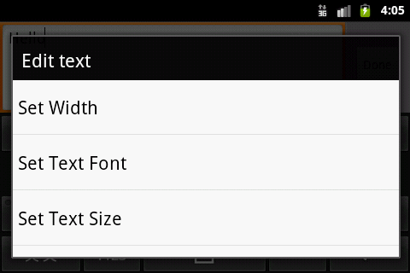
Fig 2.1 Context Menu
In order for a View to provide a context menu, you must "register" the view for a context menu. CallregisterForContextMenu () and pass it the View you want to give a context menu. When this View then receives a long-press, it displays a context menu. To define the context menu's appearance and behavior, override your activity's context menu callback methods , onCreateContextMenu() and onContextItemSelected().
In our project we have applied these features of context menu by overriding the onLongClick () an onClick () functions such that the context menu is generated on short click rather than on long click.
Options menu usage was extracted from the android developers’ website^{[14]}
The Options Menu is where you should include basic activity actions and necessary navigation items (for example, a button to open the application settings. When running on a device with Android 2.3 and lower, the Options Menu appears at the bottom of the screen. When opened, the first visible portion of the Options Menu is the icon menu. It holds the first six menu items. If you add more than six items to the Options Menu, Android places the sixth item and those after it into the overflow menu, which the user can open by touching the "More" menu item.
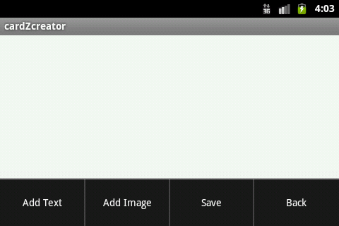
Fig 2.2 Options Menu
When the Android system creates the Options Menu for the first time, it calls activity's onCreateOptionsMenu () method. Override this method in your activity and populate the Menu that is passed into the method, Menu by inflating a menu resource as described above in Inflating a Menu Resource.
2.2 Drag and Drop Views
When creating a card from the scratch often the user needs to place the views in the location on the screen where he needs it. He must be easily moving the views on the screen. The drag and drop feature is one such option which helps the user in easy management of the position of views on the screen. By default android SDK doesn’t provide any option to drag and drop views on a layout. Hence a method to drag and drop was developed based on the launcher application that is provided by default in the android devices by Blahti.
According to Blahti^{[5]} moving views within a layout directly by a drag needs to constant updating of layout parameters of the view. This can use up a lot of CPU time and may not be as effective as required. Hence a different approach was used where in a bitmap is created for every movement of the view with the updated positions and is displayed on the screen. Finally when the view is dropped the layout parameters of the view is then changed to its new parameters and the layout is displayed. This usage of bitmaps creates an illusion to the user that the view is being dragged and is more efficient too.
According to this object model this is how a view moves on the screen. The user touches a view on the screen. The view touched signals an event, onLongClick, to its listener, which is the DragActivity. The activity turns it over to its DragController object. The controller initiates a drag operation by first getting a bitmap copy of the view, storing it in a DragView, and displaying it on the screen. As the user moves the view, the DragLayer fields all the touch events in its onTouchEvent method. It relays those events to the DragController. It watches for the end of the touch (ACTION_UP), but in the mean time, it handles the motion events by shifting the DragView to the new touch position. When the touch finally ends, the controller checks its set of DropTargets to see which one is active and if it will accept the view being dropped there. If it does, the controller calls the onDrop method of the target. In this application, the DragLayer also implements the DropTarget interface. So the onDrop call goes to the DragLayer and it takes the view being dragged and repositions it to the drop location.
Here
DragActivity – The Launcher class was turned into my DragActivity class. It is the main activity of the app.
DragLayer – implements a custom ViewGroup, which coordinates movement of views on the screen. The Launcher DragLayer is a subclass of FrameLayout. Mine is a subclass of MyAbsoluteLayout, which is a clone of the recently deprecated AbsoluteLayout class. AbsoluteLayouts allow views to be positioned to specific absolute x and y positions.
DragController – This object is the controller that does most of the work to support dragging and dropping.
DragSource – defines where a drag operation begins.
DropTarget – defines where an object can be dropped.
DragView – This is the view that you see moving around on the screen during a drag operation. It is not the actual view you want to move, but simply a bitmap that looks like the view.

2.3 Saving Layouts using Bitmaps
Once the user finishes creating his card or modifying an existing template it has to be saved. To save all the views with their layout parameters accordingly Bitmaps are used. As explained by jTribe ^{[10]} a bitmap can be created as a copy of the parent layout consisting of all of its children at their respective positions.
Firstly we can create a Bitmap object with the appropriate width and height of our view, along with a configuration.
Bitmap image = Bitmap.createBitmap (view.getWidth (), view.getHeight (), Bitmap.Config.RGB_565);
Next create a canvas with the bitmap and pass that into the draw() method of the view. This will ask the view to draw it's contents onto the canvas and therefore the associated bitmap.
view. draw (new Canvas(image));
Next insert the image into the Media library. This returns a URL that refers to the stored image and can be reused across applications.
String url = Images.Media.insertImage (getContentResolver (), image, "title", null);
Using the above functions and extending them a view or layout can also be saved with the extension specified as either PNG or JPEG.
Bitmap.compress (Bitmap.CompressFormat.JPEG, Quality, FileOutputStream);
Bitmap.compress (Bitmap.CompressFormat.PNG, Quality, FileOutputStream);
2.4 Using Dialogs
Whenever an application needs to display some additional information to the user or take input some information from the user without leaving the activity dialogs are used. A dialog is usually a small window that appears in front of the current Activity. The underlying Activity loses focus and the dialog accepts all user interaction. Dialogs are normally used for notifications that should interrupt the user and to perform short tasks that directly relate to the application in progress (such as a progress bar or a login prompt).Several predefined dialogs are implemented by extending the Dialog class such as AlertDialog, ProgressDialog, DatePickerDialog, TimePickerDialog etc. Dialogs may also be built using the Builder available in android as suggested by Dunn ^{[11]}.

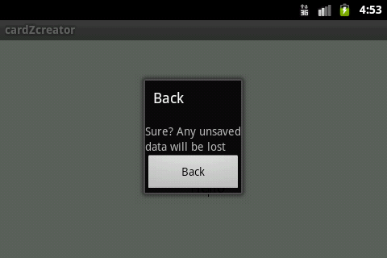
Fig 2.3 Dialog for Back
In our application we extend Dialog class to notify when a user leaves a card. This is done to unsure that the card is saved before he leaves. We use a LinearLayout with a title, message and a Button in this dialog.
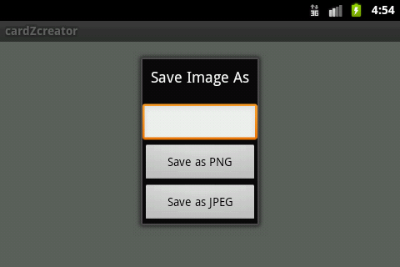
Fig 2.4 Dialog to Save
The second implementation of dialogs is used when the user wants to save his card. A dialog box containing a text field for the user to provide the name of the file being saved and options for the user to save the image as either png or jpeg. For this we use a LinearLayout consisting of title, EditText, and two buttons for two formats available to save the image.

CHAPTER 3
Modules
A well-defined segmentation of the project effort ensures system modularity. Each task forms a separate, distinct program module. At implementation time each module and its inputs and outputs are well-defined, there is no confusion in the intended interface with other system modules. At checkout time the integrity of the module is tested independently; there are few scheduling problems in synchronizing the completion of several tasks before checkout can begin. Finally, the system is maintained in modular fashion; system errors and deficiencies can be traced to specific system modules, thus limiting the scope of detailed error searching.
Our Project cardZcreator is divided into eight modules based on the functionality that they offer. They are
- Menu – First activity seen by the user
- Help – Help content for the user
- Visiting card – Development of visiting cards
- Greeting card – Development of greeting card
- Wedding card – Development of wedding card
- Template – Template handling based on users choice
- Own Card – Developing a new card
- Drag and Drop – Drag and drop views

3.1 Menu
Menu is the initial activity screen that is displayed to the user. An activity class (menu. class) is created which loads the layout of the displayed screen from the available layouts (menu.xml).The menu.xml file consists of a basic Relative Layout to which a Linear Layout consisting of list of buttons specifying the options “Visiting eCard”, “Greeting eCard”, “Wedding eCard” and “Create my own eCard”. To the bottom of Relative Layout is added another Linear Layout which consists of buttons “Help” and “Exit”. All the buttons are provided with onClickListener() function which loads the respective activity.

3.2 Help
Help activity is loaded when the “Help” button is clicked in the Menu activity. ”help. class” loads the help.xml files which defines the screen layout in help activity. A basic relative Layout is used in the help.xml file to which a ScrollView consisting of instructions on how to use the application is added.To the bottom of Relative Layout a Linear Layout is added with a button “Back” that loads the menu activity.

3.3 Visiting Card
On choosing “Visiting eCard” in the menu activity this activity is loaded. ”vcard.class” loads vcard.xml file which basically contains a Relative Layout to which a Scroll View consisting a list of buttons each specifying a template is added. To the bottom of Relative Layout a Linear Layout consisting of buttons “Help” and “Back” are added which load help and menu activities respectively when clicked. On clicking a template a new activity “vtemp.class” is loaded with the layout file chosen as per the template selected.

3.4 Greeting Card
On choosing “Greeting eCard” in the menu activity this activity is loaded. ”gcard.class” loads vcard.xml file which basically contains a Relative Layout to which a Scroll View consisting a list of buttons each specifying a template is added. To the bottom of Relative Layout a Linear Layout consisting of buttons “Help” and “Back” are added which load help and menu activities respectively when clicked. On clicking a template a new activity “gtemp.class” is loaded with the layout file chosen as per the template selected.

3.5 Wedding Card
On choosing “Greeting eCard” in the menu activity this activity is loaded. ”wcard.class” loads vcard.xml file which basically contains a Relative Layout to which a Scroll View consisting a list of buttons each specifying a template is added. To the bottom of Relative Layout a Linear Layout consisting of buttons “Help” and “Back” are added which load help and menu activities respectively when clicked. On clicking a template a new activity “wtemp.class” is loaded with the layout file chosen as per the template selected.

3.6 Template
When ant template activity is loaded based on the template selected the respective xml is loaded. Options menu is created consisting of the items “Back”, “Save” and “Help”. These are displayed when the menu button on the phone is pressed. Back option loads the template selection activity and help option loads the help activity. The save option displays a dialog in which a Edittext is provided where a user can enter the name with which the image to be saved. An option to save the image as either PNG or JPEG is also provided in the dialog.

3.7 Own Card
When “Create my own eCard” option is chosen in the menu this activity(ocard .class) is loaded. The user is initially prompted with a dialog box to choose from the different aspect ratios. On selection an empty frame with the corresponding dimensions is presented to the user. An options menu is created with the options “Add Text”, “Add Image”, “Save” and “Back”. The “Add Text” option adds an EditText to the frame. The “Add Image” option opens the gallery for the user to choose the image to be added.”Save” option is used to save the image and “Back” option is used to go back to menu activity. A context menu is also created for every view(text and image) that is added to the frame. Context menu is populated by single clicking the view. The menu consists of properties of the selected view that can be modified. To change the position of a view (text or image) long click the view until it blinks indicating that the view is selected, drag the view to the selected position on the screen and drop it.

3.8 Drag and Drop
DragController, DragLayer and DragView have been defined to handle the drag and drop of views in creation of own card. DragController handles all the code necessary for drag and drop of view like changing the layout parameters and repositioning. DragLayer is the layout screen where the drag and drop actually takes place. DragView generates the bitmap continuously with the changing position of the views and displays it on the screen. Once the image is dropped original layout with the new layout parameters is obtained.
CHAPTER 4
Architectural Design of Project
Architectural design represents the structure of data and program components that are required to build a computer-based system. It considers the architectural style that the system will take, the structure and properties of the components that constitute the system, and the interrelationships that occur among all architectural components of a system. It is a representation that enables a software engineer to (1) analyze the effectiveness of the design in meeting its stated requirements, (2) consider architectural alternatives at a stage when making design changes is still relatively easy, and (3) reducing the risks associated with the construction of the software.

  - Unified Modeling Language
4.1.1 Introduction to UML
The unified modeling language is a standard language for specifying, Visualizing,
Constructing and documenting the software system and its components. It is a graphical language that provides a vocabulary and set of semantics and rules. The UML focuses on the conceptual and physical representation of the system. It captures the decisions and understandings about systems that must be constructed. It is used to understand, design, configure, maintain and control information about the systems. The UML notation is useful for graphically depicting Object Oriented Analysis and Object Oriented Design (OOA and OOD) modules.

Visualizing

Through UML we see or visualize an existing system and ultimately we visualize how the system is going to be after implementation. Unless we think we cannot implement.UML helps to visualize how the components of the system communicate and interact with each other.

Specifying
Specifying means building models that are precise, unambiguous and complete UML addresses the specification of all the important Analysis Design, Implementation decisions that must be made in developing and deploying a software system.

Constructing
UML s models can be directly connected to a variety of programming language through mapping a model from UML to a programming language like Java or C++ or VB. Forward Engineering and Reverse Engineering is possible through UML.

Documenting
The deliverables of a project apart from coding are some artifacts which are critical in controlling, measuring and communicating about a system during its development viz.
Requirements, Architecture, Design, Source code, Project plans, Tests, Prototypes, Releases etc.

4.1.2 UML Diagrams
Diagrams are graphical presentation of set of elements. Diagrams project a system, or visualize a system from different angles and perspectives. These diagrams help in quick and fair understanding of the system.

The UML has nine diagrams these diagrams can be classified into the following two groups.

- Static Diagrams
- Dynamic Diagrams

Static or Structural Diagrams

Class diagram
This shows a set of classes, interfaces, collaborations and their relationships. There are the most common diagrams in modeling the object oriented systems and are used to give the static view of a system.

Object diagram
Shows a set of objects and their relationships and are used to show the data structures, the static snapshots of instances of the elements in a class diagram. Like class diagram, the object diagrams also address the static design view or process view of a system.

Component diagram
Shows a set of components and their relationships and are used to illustrate the static implementation view of a system. They are related to class diagrams where in components map to one or more classes, interfaces of collaborations.

Deployment diagram
Shows a set of nodes and their relationships. They are used to show the static deployment view of the architecture of a system. They are related to the component diagrams where a node encloses one or more components.

Dynamic or behavioral diagrams

Use Case diagram
Use-case Diagrams show a set of use cases and actors and their relationships. These diagrams illustrate the static use case view of a system and are important in organizing and modeling the behaviors of a system.

Sequence diagram & collaboration diagram
These two diagrams are semantically same i.e. the dynamics of a system can be modeled using one diagram and transform it to the other kind of diagram without loss of information. Both form the, Interaction diagram.

Sequence diagram
Sequence diagram is an interaction diagram which focuses on the time ordering of messages it shows a set of objects and messages exchange between these objects. This diagram illustrates the dynamic view of a system.

Collaboration diagram
This diagram is an interaction diagram that stresses or emphasizes the structural organization of the objects that send and receive messages. It shows a set of objects, links between objects and messages send and received by those objects. There are used to illustrate the dynamic views of the system.

Activity Diagrams
Activity diagram shows the flow from one activity to another within a system. The activities may be sequential or branching objects that act and are acted upon. These also show the dynamic view of the system.

  - Use Case Diagram for cardZcreator
A Use Case Diagram is “a diagram that shows the relationships among actors and use cases within a system.” Use case diagrams are often used to:
- Provide an overview of all or part of the usage requirements for a system or organization in the form of an essential model or a business model.
- Communicate the scope of a development project.
- Model your analysis of your usage requirements in the form of a system use case model.

A use case model is comprised of one or more use case diagrams and any supporting documentation such as use case specifications and actor definitions. Within most use case models the use case specifications tend to be the primary artifact with use case diagrams filling a supporting role as the “glue” that keeps your requirements model together. Use case models should be developed from the point of view of your project stakeholders and not from the (often technical) point of view of developers.
There are the basic components of a use case diagram :
- use cases
- Actors
- Relationships
- System Boundary Boxes

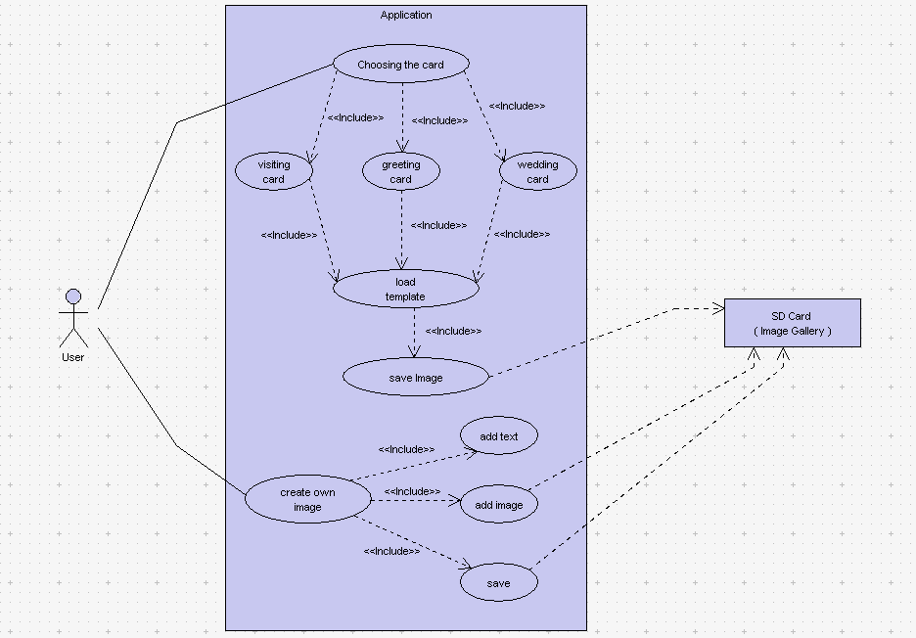
Fig 4.1 Usecase diagram of cardZcreator
  - Activity Diagram for cardZcreator
Activity diagram shows the flow from one activity to another within a system. The activities may be sequential or branching objects that act and are acted upon. These also show the dynamic view of the system.
Activity diagrams are constructed from a limited repertoire of shapes, connected with arrows. The most important shape types:
- rounded rectangles represent activities;
- diamonds represent decisions;
- bars represent the start (split) or end (join) of concurrent activities;
- a black circle represents the start (initial state) of the workflow;
- an encircled black circle represents the end (final state).

The following are the steps to be followed for an activity diagram.
- Identify the scope of the activity diagram

Begin by identifying what it is you are modeling.
- Is it a single use case?
- Is it a portion of a use case?
- Is it a business process that includes several use cases?
- Is it a single method of a class?
Once you identify the scope of your diagram, you should add a label at the top, using a note, indicating an appropriate title for the diagram and a unique identifier for it. You may also want to include the date and even the names of the authors of the diagram.

- Add start and end points
Every activity diagram has a starting point and an ending point, so you might as well add them right away. In UML Distilled (see Resources), Fowler and Scott make ending points optional. Sometimes an activity is simply a dead end but, if this is the case, then there is no harm in indicating the only transition is to an ending point. This way, when someone else reads your diagram, he or she knows you have considered how to exit these activities.

- Add activities
If you are modeling a use case, introduce an activity for each major step initiated by an actor (this activity would include the initial step, plus any steps describing the response of the system to the initial step). If you are modeling a high-level business process, introduce an activity for each major process, often a use case or a package of use cases. Finally, if you are modeling a method, then it is common to have an activity for this step in the code.

- Add transitions from the activities
My style is always to exit an activity, even if it is simply to an ending point. Whenever there is more than one transition out of an activity, you must label each transition appropriately.

- Add decision points
Sometimes the logic of what you are modeling calls for a decision to be made. Perhaps something needs to be inspected or compared to something else. Important to note is that the use of decision points is optional.

- Identify opportunities for parallel activities
Two activities can occur in parallel when no direct relationship exists between them and they must both finish before a third activity can.

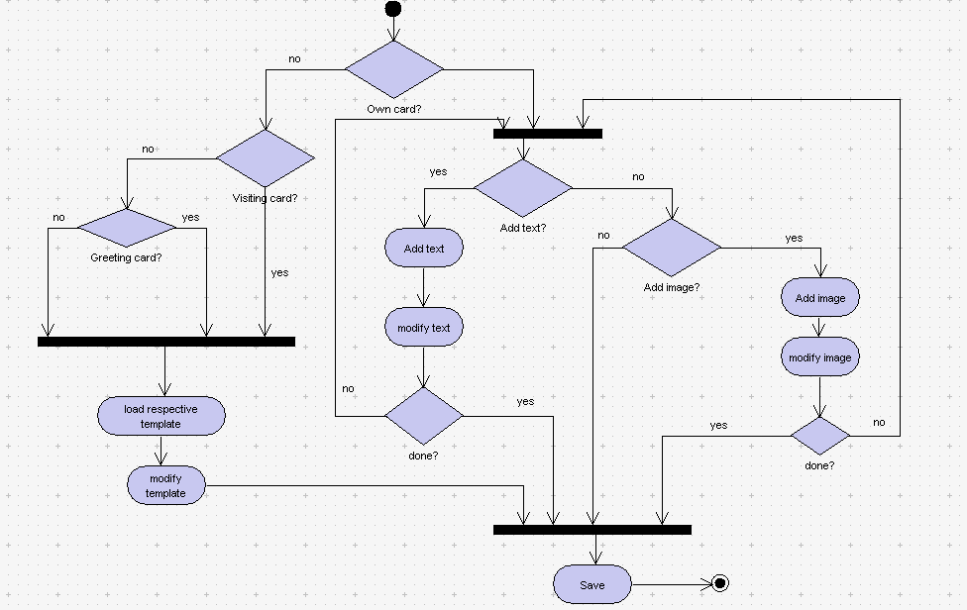
Fig 4.2 Activity diagram for cardZcreator

4.4 State Chart Diagram for cardZcreator
Statechart diagram is one of the five UML diagrams used to model dynamic nature of a system. They define different states of an object during its lifetime. And these states are changed by events. So Statechart diagrams are useful to model reactive systems. Reactive systems can be defined as a system that responds to external or internal events.
Statechart diagram describes the flow of control from one state to another state. States are defined as a condition in which an object exists and it changes when some event is triggered. So the most important purpose of Statechart diagram is to model life time of an object from creation to termination.
Statechart diagrams are also used for forward and reverse engineering of a system. But the main purpose is to model reactive system.
Following are the main purposes of using Statechart diagrams:
- To model dynamic aspect of a system.
- To model life time of a reactive system.
- To describe different states of an object during its life time.
- Define a state machine to model states of an object.

How to draw Statechart Diagram?
Statechart diagram is used to describe the states of different objects in its life cycle. So the emphasis is given on the state changes upon some internal or external events. These states of objects are important to analyze and implement them accurately.
Statechart diagrams are very important for describing the states. States can be identified as the condition of objects when a particular event occurs.
Before drawing a Statechart diagram we must have clarified the following points:
- Identify important objects to be analyzed.
- Identify the states.
- Identify the events.
During the life cycle of an object (here order object) it goes through some states and there may be some abnormal exists also. This abnormal exit may occur due to some problem in the system. When the entire life cycle is complete it is considered as the complete transaction.
Where to use Statechart Diagrams?
Statechart diagrams are used to model dynamic aspect of a system like other four diagrams disused in this tutorial. But it has some distinguishing characteristics for modeling dynamic nature. Statechart diagram defines the states of a component and these state changes are dynamic in nature. So its specific purpose is to define state changes triggered by events. Events are internal or external factors influencing the system.
Statechart diagrams are used to model states and also events operating on the system. When implementing a system it is very important to clarify different states of an object during its life time and statechart diagrams are used for this purpose. When these states and events are identified they are used to model it and these models are used during implementation of the system.
So the main usages can be described as:
- To model object states of a system.
- To model reactive system. Reactive system consists of reactive objects.
- To identify events responsible for state changes.
- Forward and reverse engineering.

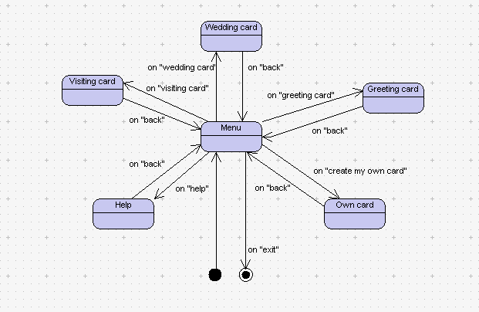
Fig 4.3 State Chart Diagram for cardZcreator

CHAPTER 5
System Requirements
5.1 Software Requirements
5.1.1 Eclipse IDE
Eclipse is a multi-language software development environment comprising an integrated development environment (IDE) and an extensible plug-in system. It is written mostly in Java and can be used to develop applications in Java and, by means of various plug-ins, other programming languages including Ada, C, C++, COBOL, Perl, PHP, Python, Ruby. In its default form it is meant for Java developers, consisting of the Java Development Tools (JDT). Users can extend its abilities by installing plug-ins written for the Eclipse software framework, such as development toolkits for other programming languages, and can write and contribute their own plug-in modules.

Eclipse employs plug-ins in order to provide all of its functionality on top of (and including) the runtime system, in contrast to some other applications where functionality is typically hard coded. The runtime system of Eclipse is based on Equinox, an OSGi standard compliant implementation. This plug-in mechanism is a lightweight software componentry framework. In addition to allowing Eclipse to be extended using other programming languages such as C and Python, the plug-in framework allows Eclipse to work with typesetting languages like LaTeX, networking applications such as telnet, and database management systems. The plug-in architecture supports writing any desired extension to the environment, such as for configuration management. Java and CVS support is provided in the Eclipse SDK, with Subversion support provided by third-party plug-ins.

With the exception of a small run-time kernel, everything in Eclipse is a plug-in. This means that every plug-in developed integrates with Eclipse in exactly the same way as other plug-ins; in this respect, all features are "created equal". Eclipse provides plug-ins for a wide variety of features, some of which are through third parties using both free and commercial models.
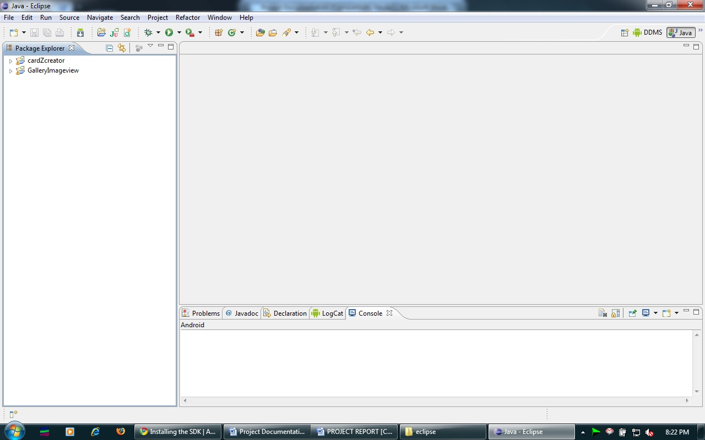
Fig 5.1 Eclipse IDE
The Eclipse SDK includes the Eclipse Java Development Tools (JDT), offering an IDE with a built-in incremental Java compiler and a full model of the Java source files. This allows for advanced refactoring techniques and code analysis. The IDE also makes use of aworkspace, in this case a set of metadata over a flat filespace allowing external file modifications as long as the corresponding workspace "resource" is refreshed afterwards.

5.1.2 Android SDK
The Android SDK provides the tools and libraries necessary to begin developing applications that run on Android-powered devices.

Before downloading Android SDK make sure that JDK is already installed in the system.
Steps involved in downloading and setting up SDK:

- Initially download the SDK starter package from [6].The SDK starter package is not a full development environment—it includes only the core SDK Tools, which you can use to download the rest of the SDK components (such as the latest Android platform).
- If you downloaded a .zip or .tgz package (instead of the SDK installer), unpack it to a safe location on your machine. By default, the SDK files are unpacked into a directory named android-sdk-<machine-platform>.
- If you downloaded the Windows installer (.exe file), run it now and it will check whether the proper Java SE Development Kit (JDK) is installed (installing it, if necessary), then install the SDK Tools into a default location (which you can modify).
- Make a note of the name and location of the SDK directory on your system—you will need to refer to the SDK directory later, when setting up the ADT plug-in and when using the SDK tools from command line.
- The last step in setting up your SDK is using the Android SDK and AVD Manager (a tool included in the SDK starter package) to download essential SDK components into your development environment.
- The SDK uses a modular structure that separates the major parts of the SDK—Android platform versions, add-ons, tools, samples, and documentation—into a set of separately installable components. The SDK starter package, which you've already downloaded, includes only a single component: the latest version of the SDK Tools. To develop an Android application, you also need to download at least one Android platform and the SDK Platform-tools (tools that the latest platform depend upon).
- If you used the Windows installer, when you complete the installation wizard, it will launch the Android SDK and AVD Manager with a default set of platforms and other components selected for you to install. Simply click Install to accept the recommended set of components and install them.
- You can launch the Android SDK and AVD Manager in one of the following ways:
From within Eclipse, select Window > Android SDK and AVD Manager.
On Windows, double-click the SDK Manager.exe file at the root of the Android SDK directory.
- To download components, use the graphical UI of the Android SDK and AVD Manager, shown in Figure 1, to browse the SDK repository and select new or updated components. The Android SDK and AVD Manager will install the selected components in your SDK environment
- By default, there are two repositories of components for your SDK: Android Repository and Third party Add-ons.

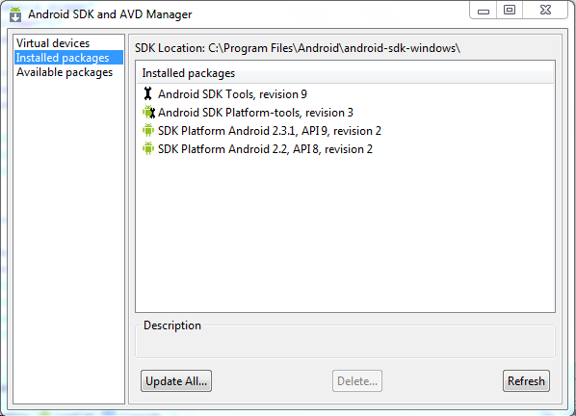
Fig 5.2 Android SDK and AVD manager

The Android Repository offers these types of components:
- SDK Tools (pre-installed in the Android SDK starter package) — Contains tools for debugging and testing your application and other utility tools. You can access these in the <sdk>/tools/ directory of your SDK and read more about them in the Tools section of the developer guide.
- SDK Platform-tools — Contains tools that are required to develop and debug your application, but which are developed alongside the Android platform in order to support the latest features. These tools are typically updated only when a new platform becomes available. You can access these in the <sdk>/platform-tools/directory. Read more about them in the Tools section of the developer guide.
- Android platforms — An SDK platform is available for every production Android platform deployable to Android-powered devices. Each platform component includes a fully compliant Android library and system image, sample code, emulator skins, and any version specific tools. For detailed information about each platform, see the overview documents available under the section "Downloadable SDK Components," at left.
- USB Driver for Windows (Windows only) — Contains driver files that you can install on your Windows computer, so that you can run and debug your applications on an actual device. You do not need the USB driver unless you plan to debug your application on an actual Android-powered device. If you develop on Mac OS X or Linux, you do not need a special driver to debug your application on an Android-powered device. (See Developing on a Device for more information about developing on a real device.)
- Samples — Contains the sample code and apps available for each Android development platform. If you are just getting started with Android development, make sure to download the samples to your SDK.
- Documentation — Contains a local copy of the latest multiversion documentation for the Android framework API.

5.1.3 ADT Plug-in for Eclipse
Android offers a custom plug-in for the Eclipse IDE, called Android Development Tools (ADT), that is designed to give a powerful, integrated environment in which to build Android applications. It extends the capabilites of Eclipse to let quickly set up new Android projects, create an application UI, debug applications using the Android SDK tools, and even export signed (or unsigned) APKs in order to distribute an application.

Downloading the ADT Plug-in
Use the Update Manager feature of your Eclipse installation to install the latest revision of ADT
Assuming that a compatible version of the Eclipse IDE installed follow these steps to download the ADT plug-in and install it in your Eclipse environment.
- Start Eclipse, then select Help > Install New Software....
- Click Add, in the top-right corner.
- In the Add Repository dialog that appears, enter "ADT Plug-in" for the Name and the following URL for the Location:
https://dl-ssl.google.com/android.eclipse
Click OK.
- In the Available Software dialog, select the checkbox next to Developer Tools and click Next.
- In the next window, you'll see a list of the tools to be downloaded. Click Next.
- Read and accept the license agreements, then click Finish.
- When the installation completes, restart Eclipse.

Configuring the ADT Plug-in
Once you've successfully downloaded ADT as described above, the next step is to modify the ADT preferences in Eclipse to point to the Android SDK directory:
- Select Window > Preferences... to open the Preferences panel (Mac OS X: Eclipse > Preferences).
- Select Android from the left panel.
- For the SDK Location in the main panel, click Browse... and locate your downloaded SDK directory.
- Click Apply, then OK.
5.2 Hardware Requirements
The hardware requirements for developing an android application are same as the requirements for the proper functioning of Eclipse. The requirements are as follows
Minimum requirements:
- Pentium 3, 500Mhz processor
- 512 MB RAM
Recommended requirements:
- Pentium 4, 1.9 Ghz processor
- 1 GB RAM
After the development of the application testing can be performed in two stages. One, within eclipse using an emulator for finding the logical errors. Second, by installing the application in an android device and checking if any hardware related errors exist.
Hence the second hardware requirement would be a mobile device running on android with following implementation specifications.
- Android API Level 7/8/9
- Device Screen resolution – QVGA / HVGA

Note: The application may work with the other configurations too but was tested only for above specifications.

CHAPTER 6
Implementation
6.1 Creating an Android Project in Eclipse
The Android Project Wizard creates all the required files for an Android application.
Open Eclipse and follow these steps to create a new project:
- Choose File, New, Android Project or click the Android Project creator icon, which looks like a folder (with the letter a and a plus sign ) on the Eclipse toolbar.
- Choose a project name.
- Choose a location for the project. Because this is a new project, select the Create New Project in Workspace radio button. Check the Use Default Location check box.
- Select a build target for your application. For most applications, you want to select the version of Android most appropriate for the devices used by your target audience and the needs of your application. If you will be using the Google add-ons (for example, Google Maps), be sure to choose the Google APIs version for your target platformlevel 7) build target is sufficient.
- Specify an application name. This name is what users will see. Specify a package name, following standard package namespace conventions for Java.
- Check the Create Activity check box. This will instruct the wizard to create a default launch Activity class for the application.
- Confirm that the Min SDK Version field is correct. This field will be set to the API level of the build target by default (Android 2.1 is API level 7). If you want to support older versions of the Android SDK, you need to change this field.
- Click the Next button.
- The Android project wizard allows you to create a test project in conjunction with your Android application.
- Click the Finish button
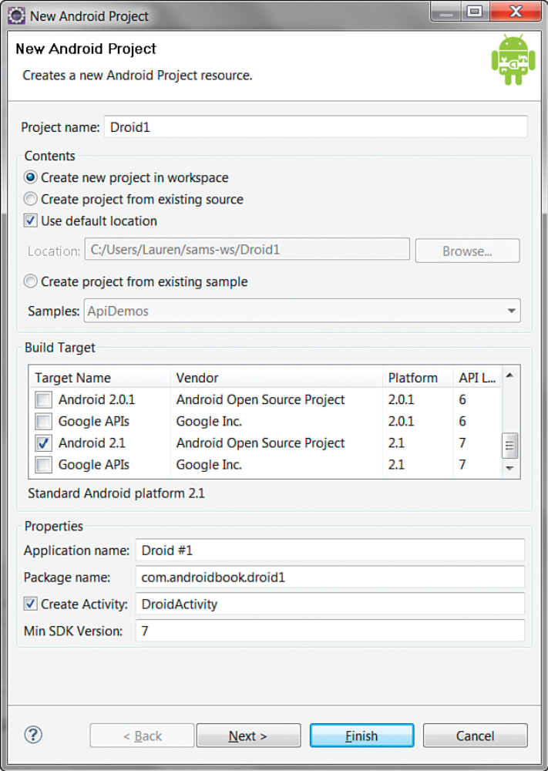
Fig 6.1 New Android Application
6.2 Project File Hierarchy
After creating a new Android project in Eclipse in addition to linking the appropriate Android SDK jar file, the following core files and directories are created:
- .AndroidManifest.xml—The central configuration file for the application.
- .default.properties—A generated build file used by Eclipse and the Android ADT plug-in. Do not edit this file.
- ./src folder—Required folder for all source code.
- ./src/com.android.packagename/MainActivity.java—Main entry point to this application, named MainActivity. This activity has been defined as the default launch activity in the Android manifest file.
- ./gen/com.android.packagename/R.java—A generated resource management source file. Do not edit this file.
- ./assets folder—Required folder where uncompiled file resources can be included in the project.
- ./res folder—Required folder where all application resources are managed. Application resources include animations, drawable graphics, layout files, data-like strings and numbers, and raw files.
- ./res/drawable—Application icon graphic resources are included in several different sizes.
- ./res/layout/main.xml—Layout file used by MainActivity to draw onscreen.
- ./res/values/strings.xml—The path where string resources are defined.
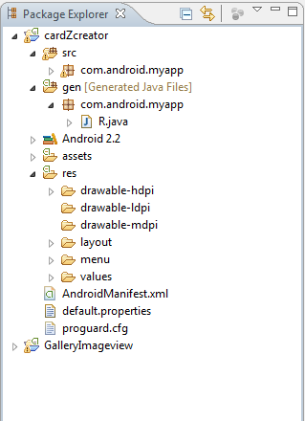
Fig 6.2 Project File Hierarchy

6.3 Setting up Emulator
To run an application in the Android emulator, you must configure an Android Virtual Device (AVD). The AVD profile describes the type of device you want the emulator to simulate, including which Android platform to support. You can specify different screen sizes and orientations, and you can specify whether the emulator has an SD card and, if so, its capacity.

Here are the steps for creating a basic AVD:
- Launch the Android SDK and AVD Manager from within Eclipse by clicking on the little green Android icon with the arrow ( ) on the toolbar. You can also launch the manager by selecting Window, Android SDK and AVD Manager in Eclipse.
- Click the Virtual Devices menu item on the left menu. The configured AVDs will be displayed as a list.
- Click the New button to create a new AVD.
- Choose a name for the AVD.
- Choose a build target. For example, to support Android 2.1, choose the item build target called Android 2.1 – API Level 7 from the drop-down.
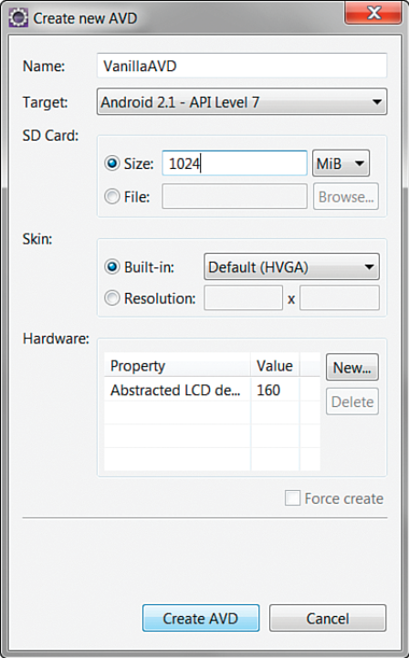
Fig 6.3 Create New AVD
- Choose an SD card capacity, in either kibibytes or mibibytes. This SD card image will take up space on your hard drive, so choose something reasonable, such as a 1024MiB or less. (The minimum is 9MiB, but keep in mind that the full size of the SD card is stored on your machine.)
- Choose a skin. This option controls the different visual looks of the emulator. In this case, go with the default HVGA screen, which will display in portrait mode.
- Click the Create AVD button and wait for the operation to complete.
- Click Finish.

6.4 Setting up SD Card for Android Emulator
By default the Android emulator does not have an SD card enabled. Hence an image of SD card has to be created within the system and its path has to be provided to the emulator for it to use the SD card. Here are the steps to be followed for setting up the SD card.
1. Create an SD card image file
In the command line you just enter the following commands:
$ cd /Developer/android-sdk-mac_x86-1.0_r1/tools/
$ ./mksdcard 256M /Users/YOUR_USER_NAME/Documents/workspace/android_sdcard
You can now check if the file has been created but if there is no error it should be there. You can also adjust the size if you want to have a smaller SD card image or even a bigger one.
2. Configuring Android emulator to start with that SD card image file
Go to: “Debug » Debug Configurations… » [select or create an Android Application debug configuration] » Target” and enter at “Additional Emulator Command Line Options” the following:
-sdcard /Users/YOUR_USER_NAME/Documents/workspace/android_sdcard
3. Adding files to SD card
Add files to the sdcard: There are two options: either you can use the two icons in the top right corner of the DDMS tools or you can use the command line tools. The following command pushes the file to your sdcard:
adb push myfile.mp3 /sdcard/
4. Copying files from SD card
The pull command in adb can be used to copy files from SD card to the system as follows
adb pull dir/file
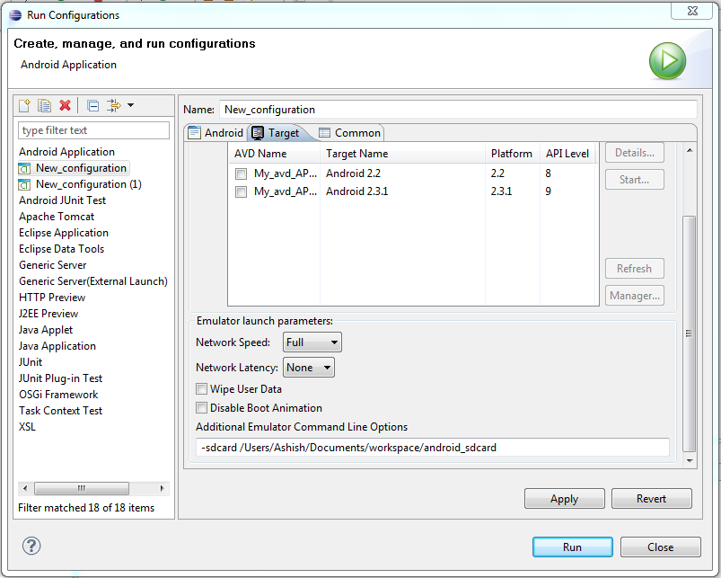
Fig 6.4 Setting up SD card with Emulator
6.5 Run/Debug Configurations
  - In Eclipse, choose Run, Debug Configurations.
  - Double-click the Android Application item to create a new entry.
  - Choose that new entry, called New_configuration.
  - Change the name of the entry to yourDebug.
  - Choose the your project by clicking the Browse button.
  - On the Target tab, check the box next to the AVD you created.
  - Apply your changes by clicking the Apply button.

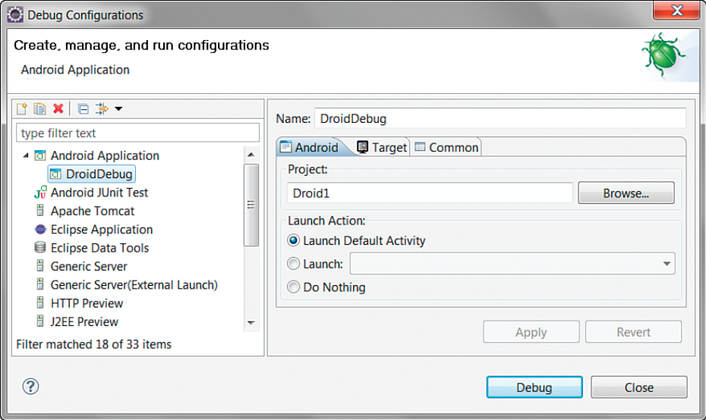
Fig 6.5 Debug Configurations

6.6 Debugging the application using DDMS
In addition to the normal Debug perspective built into Eclipse for stepping through code and debugging, the ADT plug-in adds the DDMS perspective. While you have the application running, take a quick look at this perspective in Eclipse. You can get to the DDMS perspective by clicking the Android DDMS icon in the top-right corner of Eclipse. To switch back to the Eclipse Project Explorer, simply choose the Java perspective from the top-right corner of Eclipse.

The DDMS perspective can be used to monitor application processes, as well as interact with the emulator. You can simulate voice calls and send SMS messages to the emulator. You can send a mock location fix to the emulator to mimic locationbased services.

The LogCat logging tool is displayed on both the DDMS perspective and the Debug Perspective. This tool displays logging information from the emulator or the handset, if a handset is plugged in.

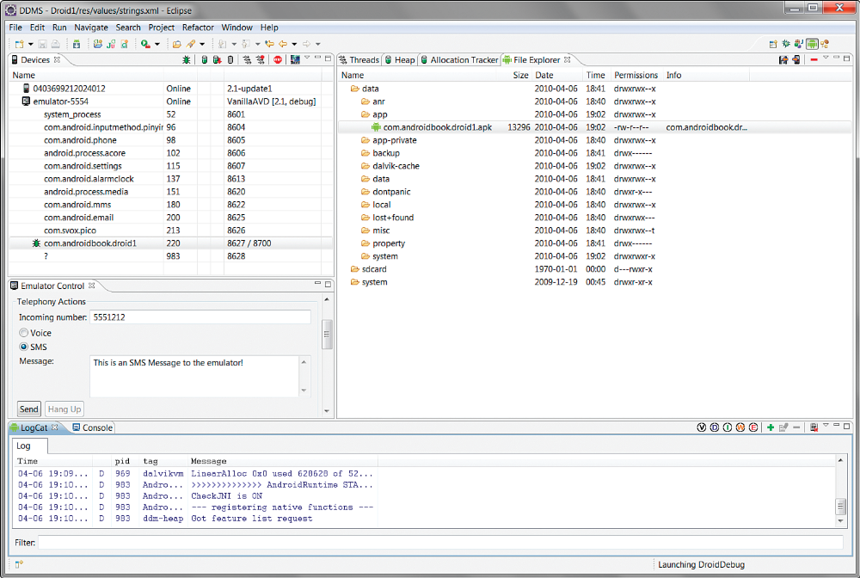
Fig 6.6 DDMS

6.7 Publishing the Application
Preparing and packaging an application for publication is called the release process The final build you perform—the build you expect to deliver to users—is called the release candidate build. The release candidate build should be rigorously tested and verified before it reaches users’ hands. If the release candidate build passes every test, it becomes the release build—the official build for publication.

To publish an Android application, take the following steps:
Prepare and perform a release candidate build of the application
- Sufficiently test the application as described in the test plan, including testing on target handsets.
- Fix and verify all defects and bugs in the application.
- Turn off all debugging diagnostics for release, including any extraneous logging that could affect application performance.
- Verify that the application icon (various sizes of PNG) is set appropriately. This icon will be seen by users and is often used by marketplaces to display the application.
- Verify that the application label is set appropriately. This represents the application name as users will see it.
- Verify that the application version name is set appropriately. The version name is a friendly version label that developers (and marketplaces) use.
- Verify that the application version code is set appropriately. The version code is a number that the Android platform uses to manage application upgrades. Consider incrementing the version code for the release candidate in order to differentiate it from the prerelease version of the application.
- Confirm that the application uses-sdk setting is set correctly. You can set the minimum, target, and maximum Android SDK versions supported with this build. These numbers are saved as the API level of each Android SDK. For example, Android 2.1 is API level 7.
- Disable the debuggable option.
- Confirm that all application permissions are appropriate. Request only the permissions the application needs with uses-permission, and make sure to request permissions the application uses, regardless of handset behavior without them.

Test the application release candidate thoroughly.
You should test the release candidate as rigorously as possible. In addition to any regular testing, you should verify that the application meets the criteria of the application marketplaces (such as the Android Market) that where you want to publish to the app.

If you find any defects or issues with the release candidate build, you must decide whether they are serious enough to stop the release process. If you decide that an issue is serious enough to require another build, you simply start the release process over again

Package and digitally sign the application.
Android application packages must be digitally signed for the Android package manager to install them. Throughout the development process, Eclipse has used a debug key to manage this process. However, for release, you need to use a real digital signature—one that is unique to you and your company. To do this, you must generate a private key.
To do this follow these steps
- In Eclipse, right-click the appropriate application project and choose the Export option.
- Under the Export menu, expand the Android section and choose Export Android Application.
- Click the Next button.
- Select the project to export. (The one you right-clicked before is the default.)
- On the keystore selection screen, choose the Create New Keystore option and enter a file location (where you want to store the key) as well as a password for managing the keystore. (If you already have a keystore, choose browse to pick your keystore file, then enter the correct password.)
- Click the Next button.
- On the Key Creation screen, enter the details of the key
- Click the Next button.
- On the “Enter destination and key/certificate checks” screen, enter a destination for the application package file.
- Click the Finish button.

Verify the signed application release thoroughly.
- Verify smooth installation of the signed application package.
- Verify that all debugging features have been disabled.
- Verify that the application is using the “live” services as opposed to any “mock” services.
- Verify that application configuration data such as the application name and icons, as well as the version information, displays correctly.

Publish the application.
After finishing the verification the .apk file is ready to be published in the android market or deployed onto any device running on android.

CHAPTER 7
Testing
Software testing is a critical element of software quality assurance and represents the ultimate review of specification, design and coding. In fact, testing is the one step in the software engineering process that could be viewed as destructive rather than constructive.

A strategy for software testing integrates software test case design methods into a well-planned series of steps that result in the successful construction of software. Testing is the set of activities that can be planned in advance and conducted systematically. The underlying motivation of program testing is to affirm software quality with methods that can economically and effectively apply to both strategic to both large and small-scale systems.

Strategic approach to software testing

The software engineering process can be viewed as a spiral. Initially system engineering defines the role of software and leads to software requirement analysis where the information domain, functions, behavior, performance, constraints and validation criteria for software are established. Moving inward along the spiral, we come to design and finally to coding. To develop computer software we spiral in along streamlines that decrease the level of abstraction on each turn.

A strategy for software testing may also be viewed in the context of the spiral. Unit testing begins at the vertex of the spiral and concentrates on each unit of the software as implemented in source code. Testing progresses by moving outward along the spiral towards integration testing, where the focus is on the design and the construction of the software architecture. Talking another turn on outward on the spiral we encounter validation testing where requirements established as part of software requirements analysis are validated against the software that has been constructed. Finally we arrive at system testing, where the software and other system elements are tested as a whole.
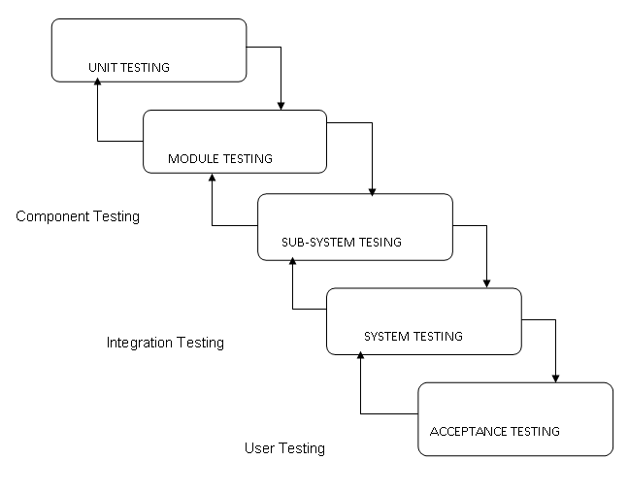
Fig 7.1 Block Diagram of Testing

7.1 Unit Testing

In computer programming, unit testing is a method by which individual units of source code are tested to determine if they are fit for use. A unit is the smallest testable part of an application. In procedural programming a unit may be an individual function or procedure. In object-oriented programming a unit is usually a method. Unit tests are created by programmers or occasionally by white box testers during the development process.
Ideally, each test case is independent from the others: substitutes like method stubs, mock objects,fakes and test harnesses can be used to assist testing a module in isolation. Unit tests are typically written and run by software developers to ensure that code meets its design and behaves as intended. Its implementation can vary from being very manual (pencil and paper) to being formalized as part of build automation.

Unit Testing for cardZcreator:
The project cardZcreator was divided into eight basic modules. The unit testing comprises of testing each of these modules individually. Each module is run in the emulator and all the options available within the module are rigorously checked. After finishing the testing the module is again run in the emulator of different API version and the process is repeated till all the features of all modules have been tested in all the API levels of deployment.
7.2 Integration Testing
Integration testing (sometimes called Integration and Testing, abbreviated "I&T") is the phase in software testing in which individual software modules are combined and tested as a group. It occurs after unit testing and before system testing. Integration testing takes as its input modules that have been unit tested, groups them in larger aggregates, applies tests defined in an integration test plan to those aggregates, and delivers as its output the integrated system ready for system testing.
The purpose of integration testing is to verify functional, performance, and reliability requirements placed on major design items. These "design items", i.e. assemblages (or groups of units), are exercised through their interfaces using Black box testing, success and error cases being simulated via appropriate parameter and data inputs. Simulated usage of shared data areas and inter-process communication is tested and individual subsystems are exercised through their input interface. Test cases are constructed to test that all components within assemblages interact correctly, for example across procedure calls or process activations, and this is done after testing individual modules, i.e. unit testing. The overall idea is a "building block" approach, in which verified assemblages are added to a verified base which is then used to support the integration testing of further assemblages.
Integration Testing for cardZcreator:
All the eight modules are interlinked and hence the connections between the modules are to be verified thoroughly. Integration testing comprises of checking the flow control of the application process from one module to another. Similar to unit teating this is tested in the emulator for all versions of API.

7.3 System Testing
System testing of software or hardware is testing conducted on a complete, integrated system to evaluate the system's compliance with its specified requirements. System testing falls within the scope of black box testing, and as such, should require no knowledge of the inner design of the code or logic.
As a rule, system testing takes, as its input, all of the "integrated" software components that have successfully passed integration testing and also the software system itself integrated with any applicable hardware system(s). The purpose of integration testing is to detect any inconsistencies between the software units that are integrated together (called assemblages) or between any of the assemblages and the hardware. System testing is a more limited type of testing; it seeks to detect defects both within the "inter-assemblages" and also within the system as a whole.
System testing is performed on the entire system in the context of a Functional Requirement Specification(s) (FRS) and/or a System Requirement Specification (SRS). System testing tests not only the design, but also the behaviour and even the believed expectations of the customer. It is also intended to test up to and beyond the bounds defined in the software/hardware requirements specification(s)
System testing for cardZcreator:
After finising the application unit and integration testing the application on the whole is installed in a device running on android and all of its features are tested.

CHAPTER 8
Result
  - Screenshots

Main Screen Menu Screen
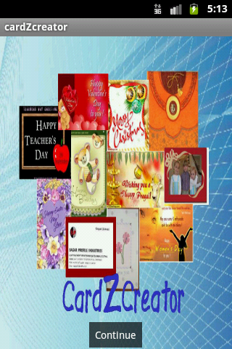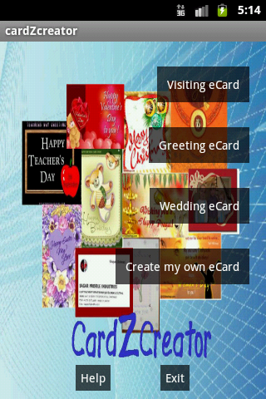

Help Screen Visiting Card
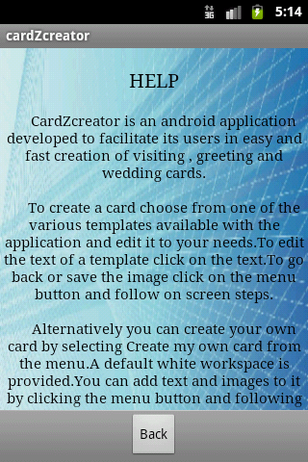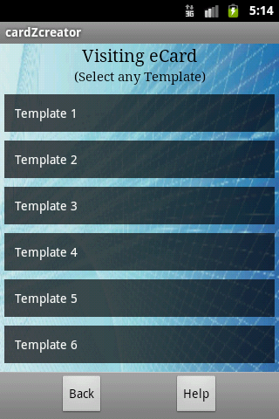

Greeting Card Wedding Card
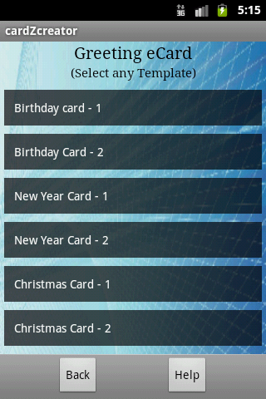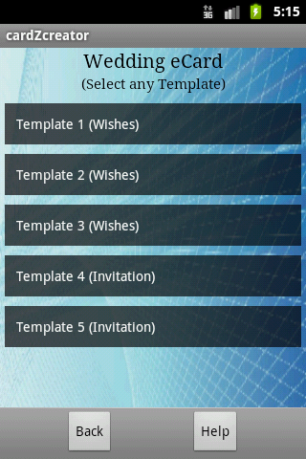

Own Card (Aspect Ratio Selection)
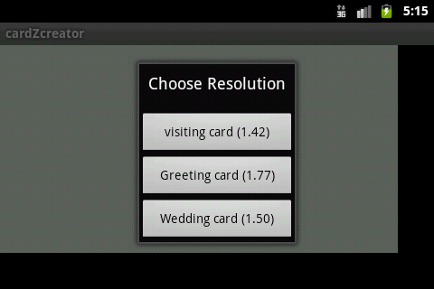

Own Card (Options Menu)
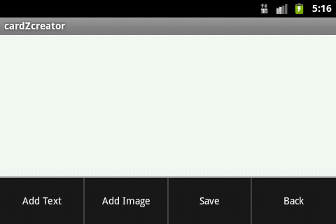

Image Save Dialog
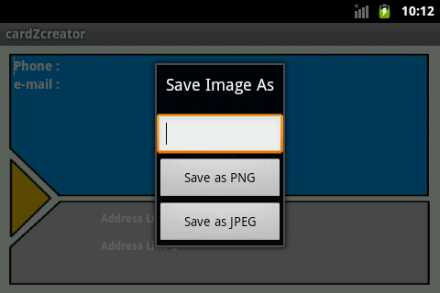

Back Dialog
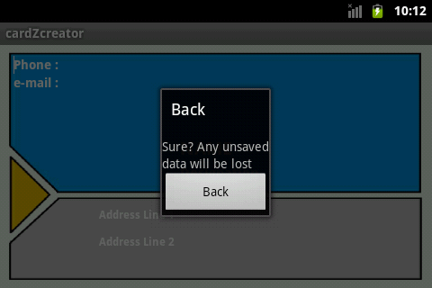
CHAPTER 9
Summary and Future Work
9.1 Limitations
- CardZcreator can only be used in mobile devices running android OS
- The size of the image saved is always less than 700 x 550
- Due to its implementation in mobile device the features of the application are very basic in nature compared to the softwares that are used in computers
- The application has been tested only for the Android API version 8 and 9. Hence its effective implementation may not be guaranteed in previous versions.

9.2 Conclusions
- CardZcreator is a mobile application that helps the user to create cards quickly.
- It can be used to create visiting/business, greeting and wedding cards.
- User can also create his own card developing it from the scratch.

9.3 Future Scope
- Future versions of cardZcreator may contain additional image editing features such as adding background images , changing image properties such as transparency etc.
- The current version limits the number of text fonts to 15 whie the next may contain more than 30 fonts.
- The advanced text editing options such as shadows, bevels, rotations etc can be added.
- A new feature to create templates and also edit the current templates can be included.

Bibliography
- Download and install Eclipse, Android SDK, ADT plugin. http://developer.android.com/sdk/index.html
- Working with android. http://developer.android.com/guide/index.html
- Android documentation. http://developer.android.com/reference/packages.html
- Android examples. http://developer.android.com/resources/index.html
- Moving views in android using drag and drop. http://blahti.wordpress.com/2011/01/17/moving-views-part-2/
- Lauren Darcey andShane conder, “Sams Teach yourself android application development” (Book)
- Reto Meier, “Professional Android application Development” (Book)
- James Steele and Nelson To, “The Android Developers Cookbook” (Book)
- Rick Rogers, John Lombardo, Zigurd Mednicks andBlake Meike, “Android Application Development” (Book)
- Saving a view as an image in android. http://jtribe.blogspot.com/2008/12/saving-view-as-image-with-android.html
- Android : Dialog box tutorial. http://developmentality.wordpress.com/2009/10/31/android-dialog-box-tutorial/
- Asim’s Rambling. http://asimmittal.net/blog/?p=128
- Open Handset Alliance : Android. http://www.openhandsetalliance.com/android_overview.html
- Creating Menus : Android. http://developer.android.com/guide/topics/ui/menus.html
- Setting up SD card within the android emulator. http://www.androiddevelopment.org/2008/11/11/how-to-create-and-use-the-sd-card-with-the-android-emulator/

